**What is Lightning App ?**

* Apps in Salesforce are a collection of tabs that work together to help the application function. It features a unique name, logo, and set of tabs. The most basic program usually has only two tabs. There are two kinds of apps:

1.Standard App: Standard apps include every instance of Salesforce by default. It has many functions such as Sales, Marketing, Community, call center, content, Salesforce chatter, App Launcher, and so on. The standard app's description, logo, and label cannot be changed.

2.Custom applications: Custom applications are developed in response to the needs of the user. Custom Apps are created by combining regular and custom tabs. Custom Apps can have their logos altered.

**Creating The Candidate Internal Result Card Lightning App.**

* To create lightning app follow the below steps:

1.From Setup, enter App Manager in the Quick Find and select App Manager.

2.Click New Lightning App.

3.Enter Candidate Internal Result Card as the App Name, then click next

4.Under App Options, leave the default selections and click next.

5.Under Utility Items, leave as is and click Next.

6.From Available Items, select Semester, Candidate, Course Details, Lecturer Details, Internalresults, Reports, and Dashboards and move them to Selected Items.

7.Click Next.

From Available Profiles, select System Administrator and move it to Selected Profiles. Click Save & Finish.

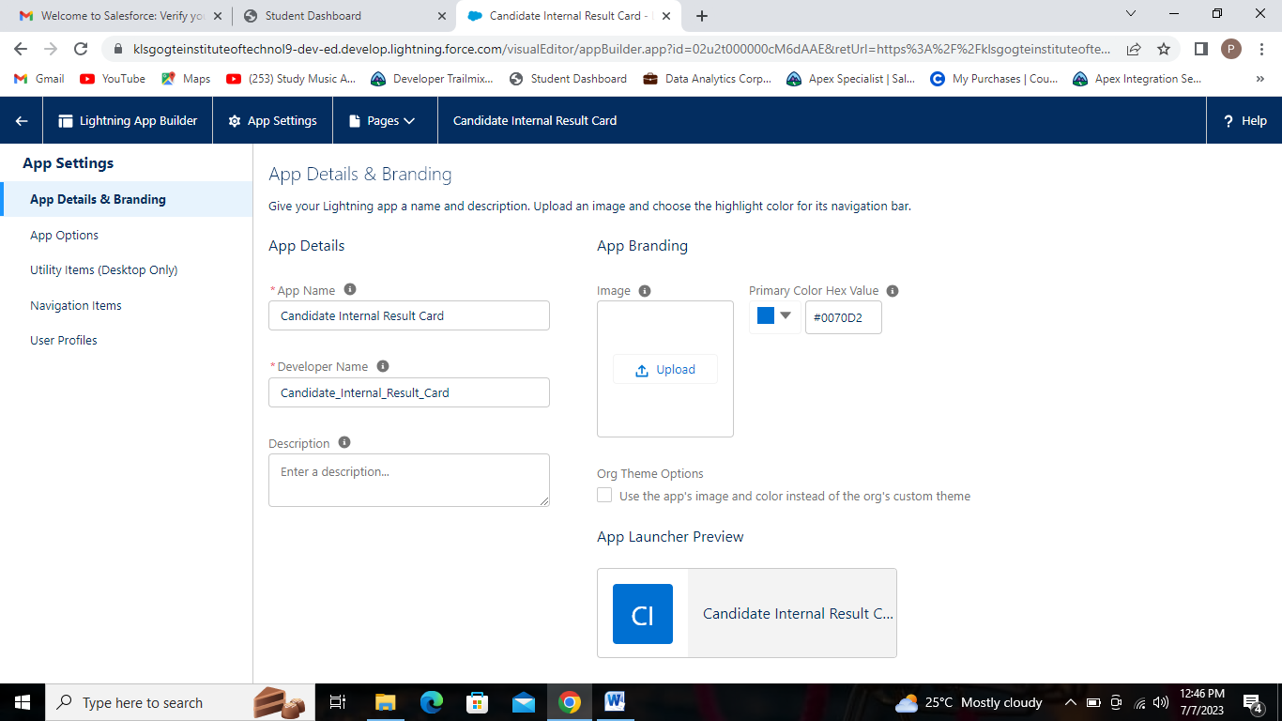

Give the app name as Candidate Internal Result Card.

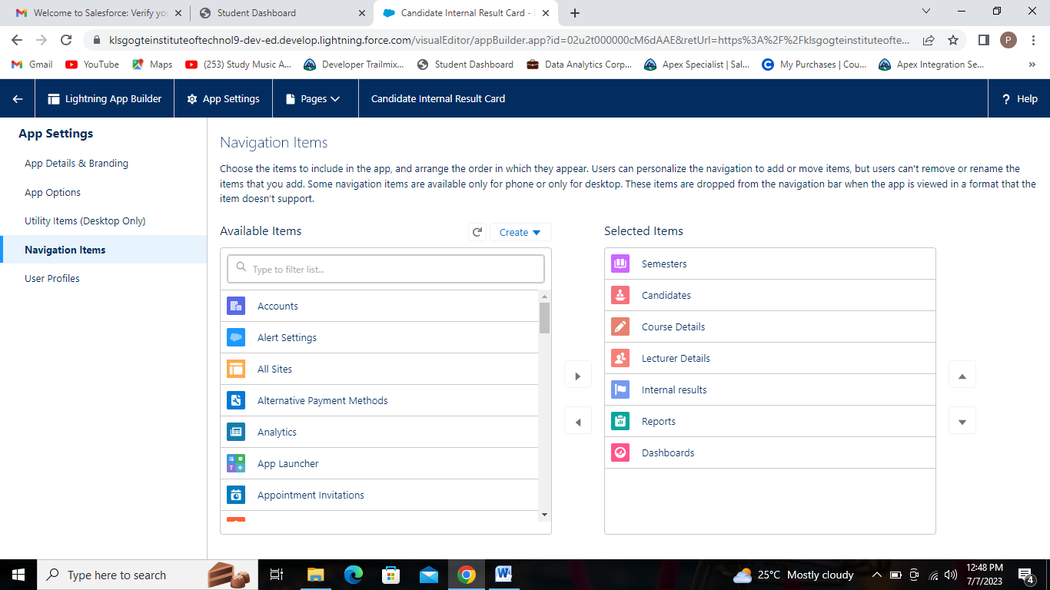

From Available Items, select Semester, Candidate, Course Details, Lecturer Details, Internal results, Reports, and Dashboards and move them to Selected Items.

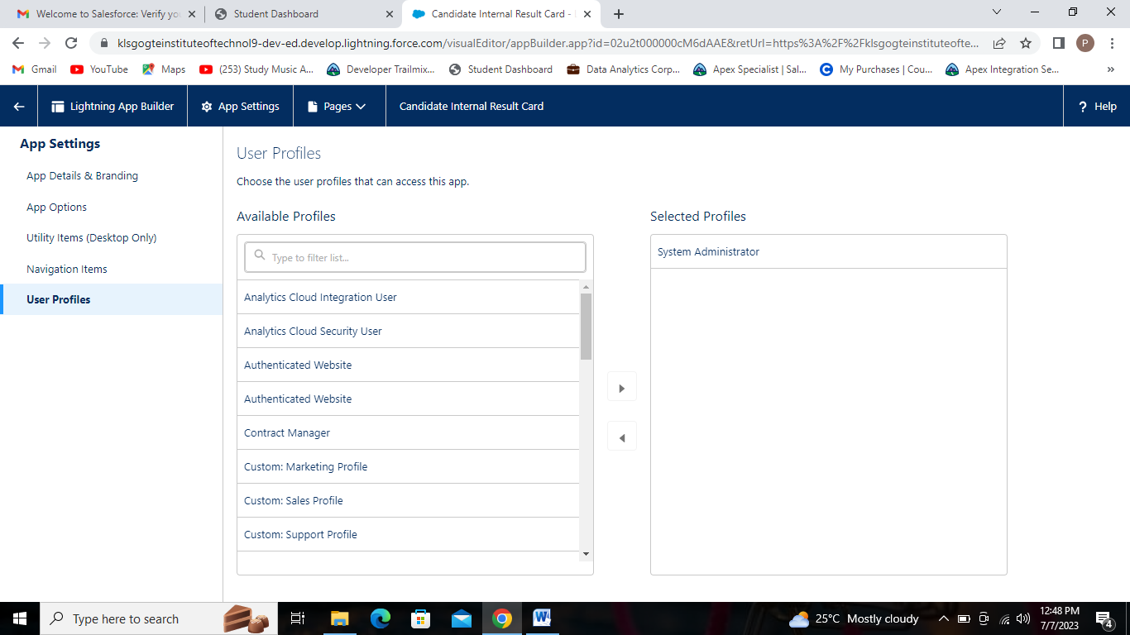

From Available Profiles, select System Administrator and move it to Selected Profiles.